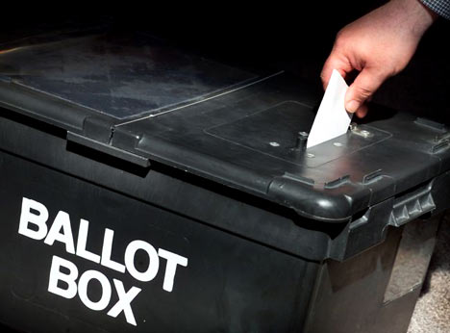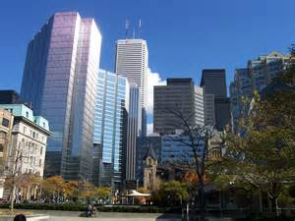

## Party supports position of trustee candidate Kerr

The Toronto Party was created for the purpose of giving a collective voice to municipal candidates running primarily for City Council. However as an organization devoted to following municipal issues and elections, we are also interested in supporting school trustee candidates. Public education is important and our children, their

# Marijuana should not be sold near schools

**Pg. 3**

THIS IS THE OFFICIAL NEWSLETTER OF THE TORONTO PARTY FOR A BETTER CITY. THE TORONTO PARTY WAS CREATED IN OCTOBER 2006 AND IS CURRENTLY TORONTO’S ONLY CIVIC ELECTORAL ORGANIZATION.

THE TORONTO PARTY

FOR A BETTER CITY

###### More inside!

EYE ON COUNCIL

WINTER 2016 ISSUE

|  |
| --- |
| Yama Arianfar |
| Austin Han |
| Kwesi Johnson |
| Kuga Kasilingham |
| **Sharon Kerr** |
| Aasia Khatoun |
| George Lin |
| Dwight McLean |
| Ron McNaughton |
| Kabitrul Mollah |
| Noah Ng |
| Andy Nguyen |
| Arjun Sahota |
| Piravena Sathiyantham |
| Neethan Shan |
| Simone Si |
| Sandeep Srivastava |
| Sahl Syed |
| Jack Wong |
| Sonny Yeung |

Data posted on the City of Toronto website, www.toronto.ca/elections

There is no doubt that the use of recreational marijuana has both short-term and long-term effects on the brain. There is also no doubt that the brain of children and young adults continues to develop until approximately the age of 25. Accordingly, the legalized use and sale of this drug is an issue that must be carefully considered, especially in areas where our schools are located, because its use can have negative impacts on student success.

With respect to short-term effects, smoking recreational marijuana, which permits its active THC component to enter into the bloodstream quickly, produces more than just a “high” as the THC interacts with brain cell receptors that play a role in normal brain development. It can alter a person’s mood, impair memory and make thinking and problem-solving more difficult.

Similarly, long-term use can reduce learning functions. According to one study, heavy use by people in their teenage years and who suffered from ongoing “cannabis use disorder” lost, on average, 8 IQ points between the ages 13 to 36.

Ward 21 TDSB candidates

### Marijuana affects brain

The Toronto Party was created in October 2006 and was later incorporated under Ontario’s Corporations Act as a corporation without share capital or not-for-profit entity.

The primary mandate of the Toronto Party has been to achieve the formal recognition of municipal political parties in Ontario and to have party affiliation included on municipal election ballots.

About the Toronto Party

Did you know that using marijuana has the following physical and mental health effects?

◊ Breathing problems, including more frequent lung illness

◊ Increased heart rate, including increased chance of heart attack

◊ Child development issues if used during pregnancy, including increased risk of brain and behavioural problems in babies

◊ temporary hallucinations and paranoia

◊ depression

◊ anxiety

◊ suicidal thoughts among teens

DID YOU KNOW?

controlled through the LCBO, should not take place within 500 metres of a school.

We strongly agree with her position.

Although there is a growing body of evidence that the medical use of marijuana can be very effective against some ailments, recreational use of the drug still has negative consequences, particularly on young developing brains.

While The Toronto Party has no position of the decriminalization of marijuana, we believe that access must be control and limited. Ms. Kerr’s proposal deserves support.

parents and society as a whole deserve trustees who always seek to promote student success.

In TDSB Ward 21, where a trustee by-election is being held, The Toronto Party has followed the campaign of child and parent advocate Sharon Kerr. She has taken the position that any legalized sale of marijuana, which Premier Wynne says should be

Toronto Party Announcements

The Toronto Party is endorsing Sharon Kerr for election to the position of TDSB Trustee in the Ward 21 by-election.

#### Candidate Kerr has good proposal

**cont.**

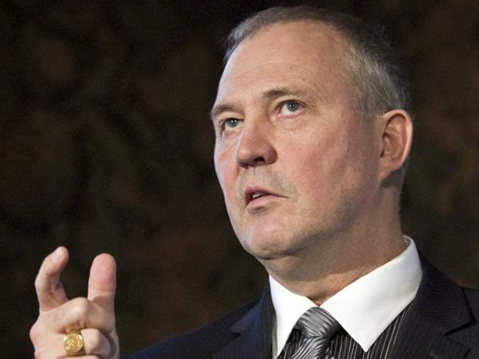

Scarborough MP and former police chief, Bill Blair, has been picked by Prime Minister Trudeau to lead the federal government’s plan to legalize marijuana.

Blair is expected to work with a three-member cabinet committee and a proposed federal-provincial-territorial task force to implement the plan.

**Future considerations?**

**Although Prime Minister Trudeau has committed the Federal Liberal government to legalizing the recreational use of marijuana and has now appointed former Toronto Police Chief and current Scarborough MP Bill Blair to implement the Liberal plan, advanced science is producing a rise in marijuana THC levels and increasing the chance of harmful effects. Edibles and the growing trend of dabbing may be providing stronger THC doses and stronger effects as well.**

**Recommended Reading and Searches**

**Legalization of the recreational use of marijuana is a controversial subject. There are harmful affects associated with the use and abuse of any drug. Accordingly, please become informed by reading pertinent information. A sample internet search is: “marijuana affects physical mental”.**

4

Membership in The Toronto Party is free.

Please sign up at: www.thetorontoparty.com

#### The Toronto Party

c/o Stephen Thiele  
Gardiner Roberts LLP  
22 Adelaide Street West, Suite 3600  
Toronto, Ontario, M5H 4E3

(P) 416-559-3424

[www.thetorontoparty.com](http://www.thetorontoparty.com)

*Gardiner Roberts LLP is in no way affiliated with The Toronto Party for a Better City and serves as a mailing address only.*

Former Police Chief Blair draws assignment

